|  |
| --- |
| **A**  **Summer Internship Report On**  **"** **E-Commerce Webapp Using Front-End"**  (IT 346 – Summer Internship - I)  **Prepared by**  PURV SAVALIA (20IT123)  **Under the Supervision of**  **Assistant Professer**  Sanket Suthar  **Submitted to**  Charotar University of Science & Technology (CHARUSAT) for the Partial Fulfillment of the Requirements for the  Degree of Bachelor of Technology (B.Tech.)  for Semester 5  **Submitted at**  home new  **Accredited with Grade A+ by NAAC**  **Accredited with Grade A by KCG**    **SMT. KUNDANBEN DINSHA PATEL DEPARTMENT OF INFORMATION TECHNOLOGY**  **Chandubhai S. Patel Institute of Technology (CSPIT)**  **Faculty of Technology & Engineering (FTE), CHARUSAT**  **At: Changa, Dist: Anand, Pin: 388421.**  **July, 2022** |



**Accredited with Grade A by NAAC Accredited with Grade A by KCG**

**CERTIFICATE**

This is to certify that the report entitled “**Website Front-End Development**” is a bonafied work carried out by **PURV SAVALIA (20IT123)** under the guidance and supervision of **Prof. Sanket Suthar** & **Mr./Ms. Name of External Guide** for the subject **Summer Internship – I (IT346)** of 5th Semester of Bachelor of Technology in **Department of Information** at Chandubhai S. Patel Institute of Technology (CSPIT), Faculty of Technology & Engineering (FTE) – CHARUSAT, Gujarat.

To the best of my knowledge and belief, this work embodies the work of candidate PURV SAVALIA, has duly been completed, and fulfills the requirement of the ordinance relating to the B.Tech. Degree of the University and is up to the standard in respect of content, presentation and language for being referred by the examiner(s).

|  |  |  |  |  |  |  |  |
| --- | --- | --- | --- | --- | --- | --- | --- |
| Under the supervision of,  SANKET SUTHAR  Assistant Professer  Smt. Kundanben Dinsha Patel Department of Information Technology  CSPIT, FTE, CHARUSAT, Changa, Gujarat | Mr. Daxesh Paneliya  Director  CYGNUX SOFTTECH.PVT.LTD. |  |  |  |  |  |  |
| Dr. (Prof.) Parth Shah  Head of Department (IT)  CHARUSAT, Changa, Gujarat. |  |  |  |  |  |  |  |

**Chandubhai S. Patel Institute of Technology (CSPIT) Faculty of Technology & Engineering (FTE), CHARUSAT**

At: Changa, Ta. Petlad, Dist. Anand, Pin: 388421. Gujarat.

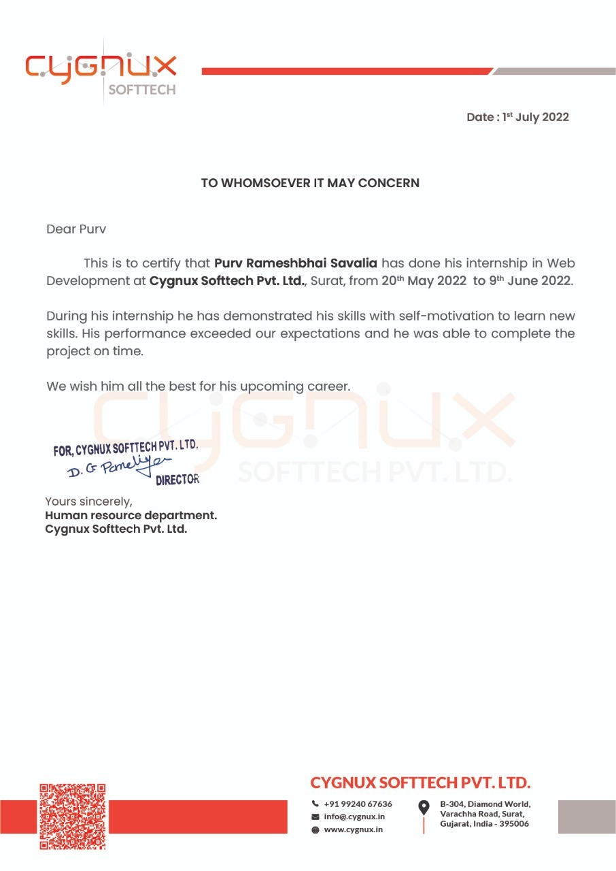

**ACKNOWLEDGEMENT**

We are really grateful to our Dr. (Prof.) Parth Shah, HOD, Bachelor of Technology in **Department of Information,** for providing me with an opportunity to undertake this internship in **CYGNUX SOFTTECH Pvt. Ltd.** and providing me with all the facilities. I am highly thankful to Prof. Sanket Suthar for their active support, valuable time and advice during the project and in completing the assignment of preparing the said project within the time stipulated.

Lastly, I am thankful to all those, particularly the various friends, who have been instrumental in creating proper, healthy and conductive environment and including new and fresh innovative ideas for me during the Internship, their help, it would have been extremely difficult for me to prepare the project in a time bound framework.

i

**ABSTRACT**

This is an internship report mainly includes the general information regarding the company “**CYGNUX SOFTTECH Pvt. Ltd.**”, detailed description of experience I had in the company, the skills I acquired from the experienced cooperate people, my training, my task and the live project I completed in offline mode in internship.

This summer internship provided me with a team experience and helped me in develop my skills in Web development using HTML5, CSS3, JavaScript. I have worked with development of front end and designing of a Company’s Website and Dashboard.

Overall, the Internship program helped me in different ways to grow my knowledge in the field of IT and also gave me an insight on how to work in a team with proper coordination and in a timely manner.

ii

**TABLE OF CONTENTS**

**Acknowledgement i**

**Abstract ii**

**Company Description iv**

**Chapter 1: INTRODUCTION 5**

* 1. Purpose of Internship 5
  2. Overview of Internship 5
  3. Objective 5
  4. Roles and Responsibilities 5
  5. Internship Plan (Week Wise) 6

**Chapter 2: APPLICATIONS OF PROJECT 7**

* 1. Application1 7
  2. Application2 7
  3. GUI Flow Chart 8

**Chapter 3: SOFTWARE DESIGN 9**

* 1. IMPLEMENTATION-TASK 1 9
  2. IMPLEMENTATION-TASK 2 10
  3. IMPLEMENTATION-TASK 3 11
  4. IMPLEMENTATION-TASK 4 12
  5. IMPLEMENTATION-TASK 5 13
  6. IMPLEMENTATION-TASK 6 14

**Chapter 4: CONCLUSION AND DISCUSSION 15**

* 1. Problem Encountered and Possible Solutions 15
  2. Conclusion 15



iii

CSPIT Smt Kundaben Dinsha Patel Department of Information Technology

**LIST OF FIGURES**

2.3.1 Website Flowchart 8

* + - 1. Book Trial Page 9
      2. Validation of Information 9

3.2.1.1 Main login page for Teacher & Student 10

* + - 1. Teacher Dashboard login page 11
      2. Student Dashboard login page 11
      3. Handbook Section having all details 12
      4. Sub-section having hover effect 12
      5. Courses having level-vise buttons 13
      6. Hover effect for each course(Course button) 13

3.6.1.1 Setting page view 14

**List of Tables**

Table I Company Details iv

Table 1.5.1 Internship Activities vi

Table 3.1.1 Task 1 9

Table 3.2.1 Task 2 10

Table 3.3.1 Task 3 11

Table 3.4.1 Task 4 12

Table 3.5.1 Task 5 13

Table 3.6.1 Task 6

iv

**CHAPTER 1: INTRODUCTION**

* 1. **PURPOSE OF INTERNSHIP**

The purpose of this internship was to upskill my web development using HTML,CSS and JavaScript in the pandemic situation and not just wasting my time sitting idle in home and getting hands-on experience of how to work in a team to develop a web application with all the side cases testedand try to give out a code without much errors in it.

* 1. **OVERVIEW OF INTERNSHIP**

In the Initial stage I was given a small task to prepare a small “Book Trial” form using HTML5, CSS3, Bootstrap, and later on it was told that the form should sent a mail to the registered user. Later on, we were explained about the whole web application that we needed to develop during our internship that included a teacher dashboard, student dashboard and a customer side website. Tasks were divided among the frontend team and we had to design it according to the UI/UX design which was provided by the design team. The internship helped me in learning different aspects of team work.

* 1. **OBJECTIVE**

The main objective is to design and develop website and user friendly dashboard at **CYGNUX SOFTTECH Pvt. Ltd.**

* 1. **ROLES & RESPONSIBILITES**
     + Role: Front-End Developer

Responsibilities: The responsibilities are to develop and design a responsive website and to create a user friendly module for the students and teachers

* 1. **INTERNSHIP PLAN (WEEK WISE)**

*Table 1.5.1 Internship Activities*

|  |  |  |
| --- | --- | --- |
|  | **Date** | **Name of Topic/Module** |
| **Week 1** | 20/05/2022 – 23/05/2022 | Introduction of Company, Internship plan discussion, Code walkthrough, understanding the functionalities and working, Starting with basic tasks and then after gone with live project is “Patel-papad”. |
| **Week 2** | 24/05/2022 – 28/05/2022 | In live Project i.e “Patel-papad” , I have done some basic changes according to the client .After finishing all tasks in “Patel-papad” , we have move to another client. done all Finalizing the design, design of Angrez-Hair saloon form, discussing design flow of login pages |
| **Week 3** | 30/05/2022 – 02/06/2022 | Designing the pages for clients and user individually, understanding the layout of the design, changing according to page layouts of different devices, learn  to create responsive pages |
| **Week 4** | 03/06/2022 – 06/06/2022 | Handbook section design, adding button and hover functionalities, brainstorming on designs of next sections |
| **Week 5** | 13/06/2022 – 16/06/2022 | Creation of courses section, understanding the flow of subsections, inner section logic |

**CHAPTER 2: APPLICATIONS OF PROJECT**

* 1. **APPLICATION 1**
     + The users will be able to view all the information about the company from the website and also will be able to book their slot using the website page that submit all the details filled up by the user into the admin dashboard, and also the customer will get a direct email and message on their registered details.
     + The login page and sign up page helps the User as well as admin to login into their respective dashboards
  2. **APPLICATION 2**

Admin Dashboard will have:-

* + - In admin section , the we have make user-friendly interface , so admin easily access and analyze the data.
    - Admin can see how many sales are done in this month and how many revenue is generated in current month.

**CHAPTER 3: SOFTWARE DESIGN**

* 1. **IMPLEMENTATION-TASK 1**

*Table 3.1.1 Task 1*

|  |  |
| --- | --- |
| **Task 1** | |
| **Task Description** | Created web-pages using Bootstrap  We have created user-friendly webpages. |
| **Output Screenshots** | *3.1.1 Home Page*          *3.1.1 About Page* |
|  |  |

* 1. **IMPLEMENTATION-TASK 2**

*Table 3.2.1 Task 2*

|  |  |
| --- | --- |
| **Task 2** | |
| **Task Description** | Patel-Papad live project  Here we have do certain changes according to the client like changes of photos and  Align the texts and some css changes according to layout. |
| **Output Screenshots** |  |

* 1. **IMPLEMENTATION-TASK 3**

*Table 3.3.1 Task 3*

|  |  |
| --- | --- |
| **Task 3** | |
| **Task Description** | * In “Angrez” client we have created a component which name is ‘Stock’ , API for Display the data into database and created database in xampp server and inserted some dommy database. |
| **Output Screenshots** | * + - 1. *Stock component*        * + - 1. API for Display the data into database      * + - 1. Database and Data Insert |

* 1. **IMPLEMENTATION-TASK 4**

*Table 3.4.1 Task 4*

|  |  |
| --- | --- |
| **Task 4** | |
| **Task Description** | API for Display, Insert, Update, Delete. Database and Data Insert , Data Update, Delete , Search filter in Stock and Expanses Component Frontend |
| **Output Screenshots** | * API for Display, Insert, Update, Delete          * Database and Data Insert              * Data Update, Delete            * Search filter in stock |

* 1. **IMPLEMENTATION-TASK 5**

*Table 3.5.1 Task 5*

|  |  |
| --- | --- |
| **Task 5** | |
| **Task Description** | Implement a Component whose name is ‘Vendor’ Front-end ,Make a Form which open at another page , A customer can easily fill the form and It store at database , Search, Update & Delete.  Vendor Component Back-end APIs. |
| **Output Screenshots** | * A Vendor Component      * Add Vendor          * Data Update, Delete            * View or edit a vendor |

**CHAPTER 4: CONCLUSION AND DISCUSSION**

* 1. **PROBLEM ENCOUNTERED AND POSSIBLE SOLUTIONS**
     + One of the problem encountered that the layout wasn’t getting adjusted as per the size of the devices. This was solved by using bootstrap and creating it responsive.
     + Another problem encountered was that, how to prevent an individual only register once and hence reducing multiple users with same information. For this we added a functionality that once a user registers with an email, cannot register again.
  2. **CONCLUSION**
     + The Internship helped in giving a bit insight of how the corporate world feels like and the importance of team work in a project to complete the project in a timely manner.
     + The Internship also helped me learn a lot of new technical stuff such as responsiveness of a website, JavaScript framework etc.

**CHAPTER 5: REFERENCES**

* + - [Bootstrap Documentation](https://getbootstrap.com/docs/4.1/getting-started/introduction/)
    - [Form Validation using JavaScript](https://www.youtube.com/watch?v=Gku9iMSMbWg)
    - [JavaScript Beginners Handbook](https://www.freecodecamp.org/news/the-complete-javascript-handbook-f26b2c71719c/)
    - [GUI Designing Guide](https://www.creativebloq.com/features/ui-design)